# Supporting Information

## *Experimental plots*

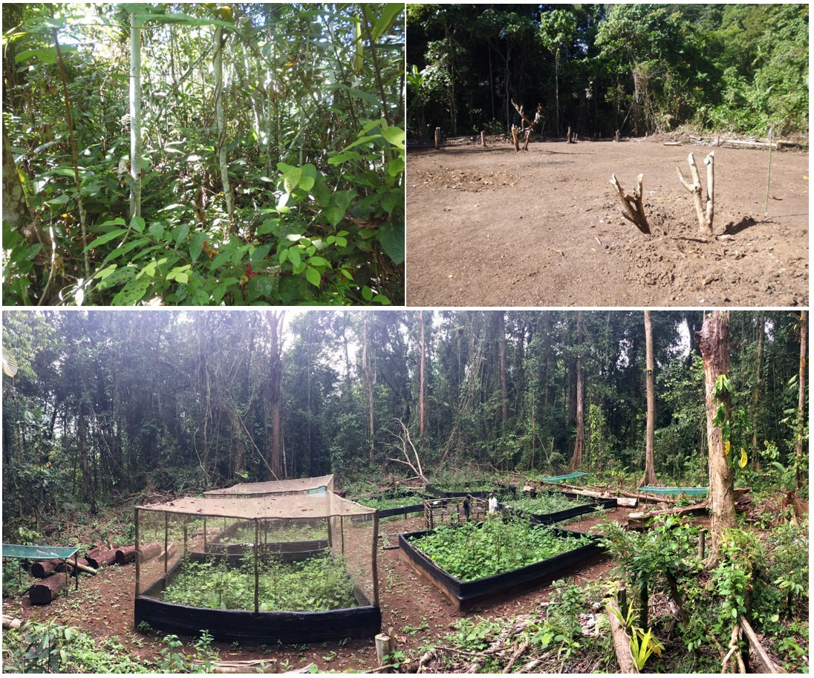

**A**

**B**

**C**

Fig. S1. Example experimental block. A – early secondary succession prior to the experiment. B – newly initiated succession. C – experimental setup with initial regenerating vegetation.

## *Plant species codes*

Table S1. Plant species found in all experimental plots with their abbreviated codes used in the main text, cumulative biomass (in kg) and life form classification.

|  |  |  |  |  |
| --- | --- | --- | --- | --- |
| ***No.*** | ***Species name*** | ***Code*** | ***Biomass*** | ***Life form*** |
| 1 | Abrus precatorius | ABRUPR | 0.727 | vine |
| 2 | Ageratum conyzoides | AGERCO | 23.899 | herb |
| 3 | Amaranthus lividus | AMARLI | 0.147 | herb |
| 4 | Amomum aculatum | AMOMAC | 0.005 | herb |
| 5 | Amomum maximum | AMOMMA | 0.035 | herb |
| 6 | Artocarpus communis | ARTOCO | 0.028 | tree |
| 7 | Artocarpus lakoocha | ARTOLA | 0.081 | tree |
| 8 | Axonopus compressus | AXONCO | 0.3 | grass |
| 9 | Barringtonia sp.1 | BARRS1 | 0.015 | tree |
| 10 | Bidens pilosa | BIDEPI | 1.412 | herb |
| 11 | Breynia cernua | BREYCE | 14.007 | shrub |
| 12 | Calopogonium mucunoides | CALOMU | 19.598 | vine |
| 13 | Carica papaya | CARIPA | 1.095 | tree |
| 14 | Commersonia bartramia | COMMBA | 35.838 | tree |
| 15 | Cordyline terminalis | CORDTE | 36.39 | herb |
| 16 | Costus speciosus | COSTSP | 2.078 | herb |
| 17 | Crassocephalum crepidioides | CRASCR | 0.411 | herb |
| 18 | Cucurbita sp. | CUCUS1 | 12.14 | herb |
| 19 | Cyperus bifax | CYPHBI | 0.42 | sedge |
| 20 | Cyperus involucratus | CYPHIN | 0.103 | sedge |
| 21 | Cyperus rotundus | CYPHRO | 0.588 | sedge |
| 22 | Davallia denticulata | DAVADE | 0.151 | fern |
| 23 | Dendrocnide longifolia | DENDLO | 0.095 | tree |
| 24 | Dendrocnide sp. | DENDS1 | 0.114 | tree |
| 25 | Dichapetalum papuanum | DICHPA | 0.033 | vine |
| 26 | Dioscorea sp. | DIOSS1 | 0.307 | vine |
| 27 | Dracena angustifolia | DRACAN | 0.485 | sedge |
| 28 | Dracontomelon lanceolatum | DRACLA | 0.12 | tree |
| 29 | Endospermum labios | ENDOLA | 0.084 | tree |
| 30 | Etlingera labiosa | ETLILA | 0.39 | herb |
| 31 | Euphorbia geniculata | EUPHGE | 0.536 | herb |
| 32 | Euphorbia hirta | EUPHHI | 0.3 | herb |
| 33 | Faradaya splendida | FARASP | 0.69 | vine |
| 34 | Ficus congesta | FICUCO | 7.318 | tree |
| 35 | Ficus copiosa | FICUCP | 7.65 | tree |
| 36 | Ficus hahliana | FICUHA | 0.017 | tree |
| 37 | Ficus hispidoides | FICUHI | 11.23 | tree |
| 38 | Ficus pachyrrhachis | FICUPA | 2.428 | tree |
| 39 | Ficus variegata | FICUVA | 0.243 | tree |
| 40 | Ficus wassa | FICUWA | 0.732 | tree |
| 41 | Guioa comesperma | GUIOCO | 0.031 | tree |
| 42 | Homalanthus novoguineensis | HOMANO | 2.55 | tree |
| 43 | Hornstedtia lycostoma | HORNLY | 0.186 | herb |
| 44 | Hornstedtia scottiana | HORNSC | 0.007 | herb |
| 45 | Hyptis capitata | HYPTCA | 1.717 | herb |
| 46 | Ichnanthus vicinus | ICHNVI | 0.067 | herb |
| 47 | Imperata cyllindrica | IMPECY | 39.115 | grass |
| 48 | Ipomea batata | IPOMBA | 15.504 | vine |
| 49 | Ipomea sp. | IPOMS1 | 7.518 | vine |
| 50 | Leea indica | LEEAIN | 0.045 | shrub |
| 51 | Lepistemon urceolatus | LEPIUR | 0.854 | vine |
| 52 | Macaranga aleurotoides | MACAAL | 0.25 | tree |
| 53 | Macaranga bifoveata | MACABI | 0.771 | tree |
| 54 | Macaranga fallacina | MACAFA | 0.049 | tree |
| 55 | Macaranga quadriglandulosa | MACAQU | 23.1 | tree |
| 56 | Macaranga tanarius | MACATA | 13.444 | tree |
| 57 | Manihot esculenta | MANIES | 7.65 | tree |
| 58 | Marsdenia velutina | MARSVE | 1.365 | vine |
| 59 | Melanolepis multiglandulosa | MELAMU | 363.041 | tree |
| 60 | Melochia sp. | MELOS1 | 451.995 | tree |
| 61 | Merremia peltata | MERRME | 5.813 | tree |
| 62 | Merrilliodendron megacarpus | MERRPE | 0.017 | vine |
| 63 | Mikania micrantha | MIKAMI | 90.337 | vine |
| 64 | Mussaenda cylindrocarpa | MUSSCY | 0.003 | shrub |
| 65 | Oplismenus compositus | OPLICO | 0.142 | grass |
| 66 | Parsonia sp. | PARSS1 | 0.365 | vine |
| 67 | Paspalum conjugatum | PASPCO | 78.514 | grass |
| 68 | Paspalum sp. | PASPS1 | 10.806 | grass |
| 69 | Paspalum sp. | PASPS2 | 0.103 | grass |
| 70 | Paspalum sp. | PASPS3 | 0.106 | grass |
| 71 | Passiflora foetida | PASSFO | 2.489 | vine |
| 72 | Phylacium bracteosum | PHYLBR | 0.735 | vine |
| 73 | Physalis angulata | PHYSAN | 0.009 | herb |
| 74 | Piper aduncum | PIPEAD | 3.118 | tree |
| 75 | Piper betle | PIPEBE | 0.009 | vine |
| 76 | Piper umbellatum | PIPEUM | 10.892 | tree |
| 77 | Piptrus argenteus | PIPTAR | 985.49 | tree |
| 78 | Pisonia longirostris | PISOLO | 0.162 | tree |
| 79 | Premna obtusifolia | PREMOB | 11.565 | tree |
| 80 | Premna sp. | PREMS1 | 7.9 | tree |
| 81 | Pueraria triloba | PUERTR | 0.095 | vine |
| 82 | Sida rhombifolia | SIDARH | 0.161 | herb |
| 83 | Smilax australis | SMILAU | 0.002 | vine |
| 84 | Solanum sp. | SOLAS1 | 1.422 | herb |
| 85 | Sorghum propinquum | SORGPR | 9.125 | grass |
| 86 | Sphaerostephanos altallus | SPHAAL | 0.137 | fern |
| 87 | Sphaerostephanos unitus | SPHAUN | 4.068 | fern |
| 88 | Stachytarpheta urticaefolia | STACUR | 29.789 | herb |
| 89 | Stemona papuana | STEMPA | 0.079 | vine |
| 90 | Synedrella nodiflora | SYNENO | 75.265 | herb |
| 91 | Tournefortia sarmentosa | TOURSA | 1.533 | shrub |
| 92 | Trema orientalis | TREMOR | 288.463 | tree |
| 93 | Trichospermum pleiostigma | TRICPL | 90.099 | tree |
| 94 | Uncaria lanosa | UNCALA | 0.031 | vine |
| 95 | Urena lobata | URENLO | 2.67 | herb |
| 96 | Vitex coffasus | VITECO | 1.11 | tree |

## *Polyphagy of the Oribius sp. Beetle*

## Fig. S2. Feeding preferences of *Oribius* sp. weevil. Values on the y axis represent the percentage of 20 no-choice feeding trials using an excised leaf and a single specimen of *Oribius* sp. beetle (placed in a container, after the beetle had been starved 24 hours) during which large feeding damage (defined as leaf holes bigger than body size projection of the beetle) occurred in 24 hours.

## *Within- and between- treatment beta-diversity*

We calculated multiple-site abundance-based Bray-Curtis dissimilarity (Baselga, 2017) and partitioned total beta-diversity into the component derived from species turnover (balance) and the component based on species gain and loss derived from nestedness (gradient). We used biomass as a measure of abundance.

All values of within-treatment dissimilarity are high, >0.75, and the component related to species turnover between sites dominates in all cases. The low nestedness component suggests that communities mainly change through species turnover rather than species loss from high- to low-diversity communities. This situation is different only in the insecticide treatment, where the communities are more similar and nested than in other treatments.

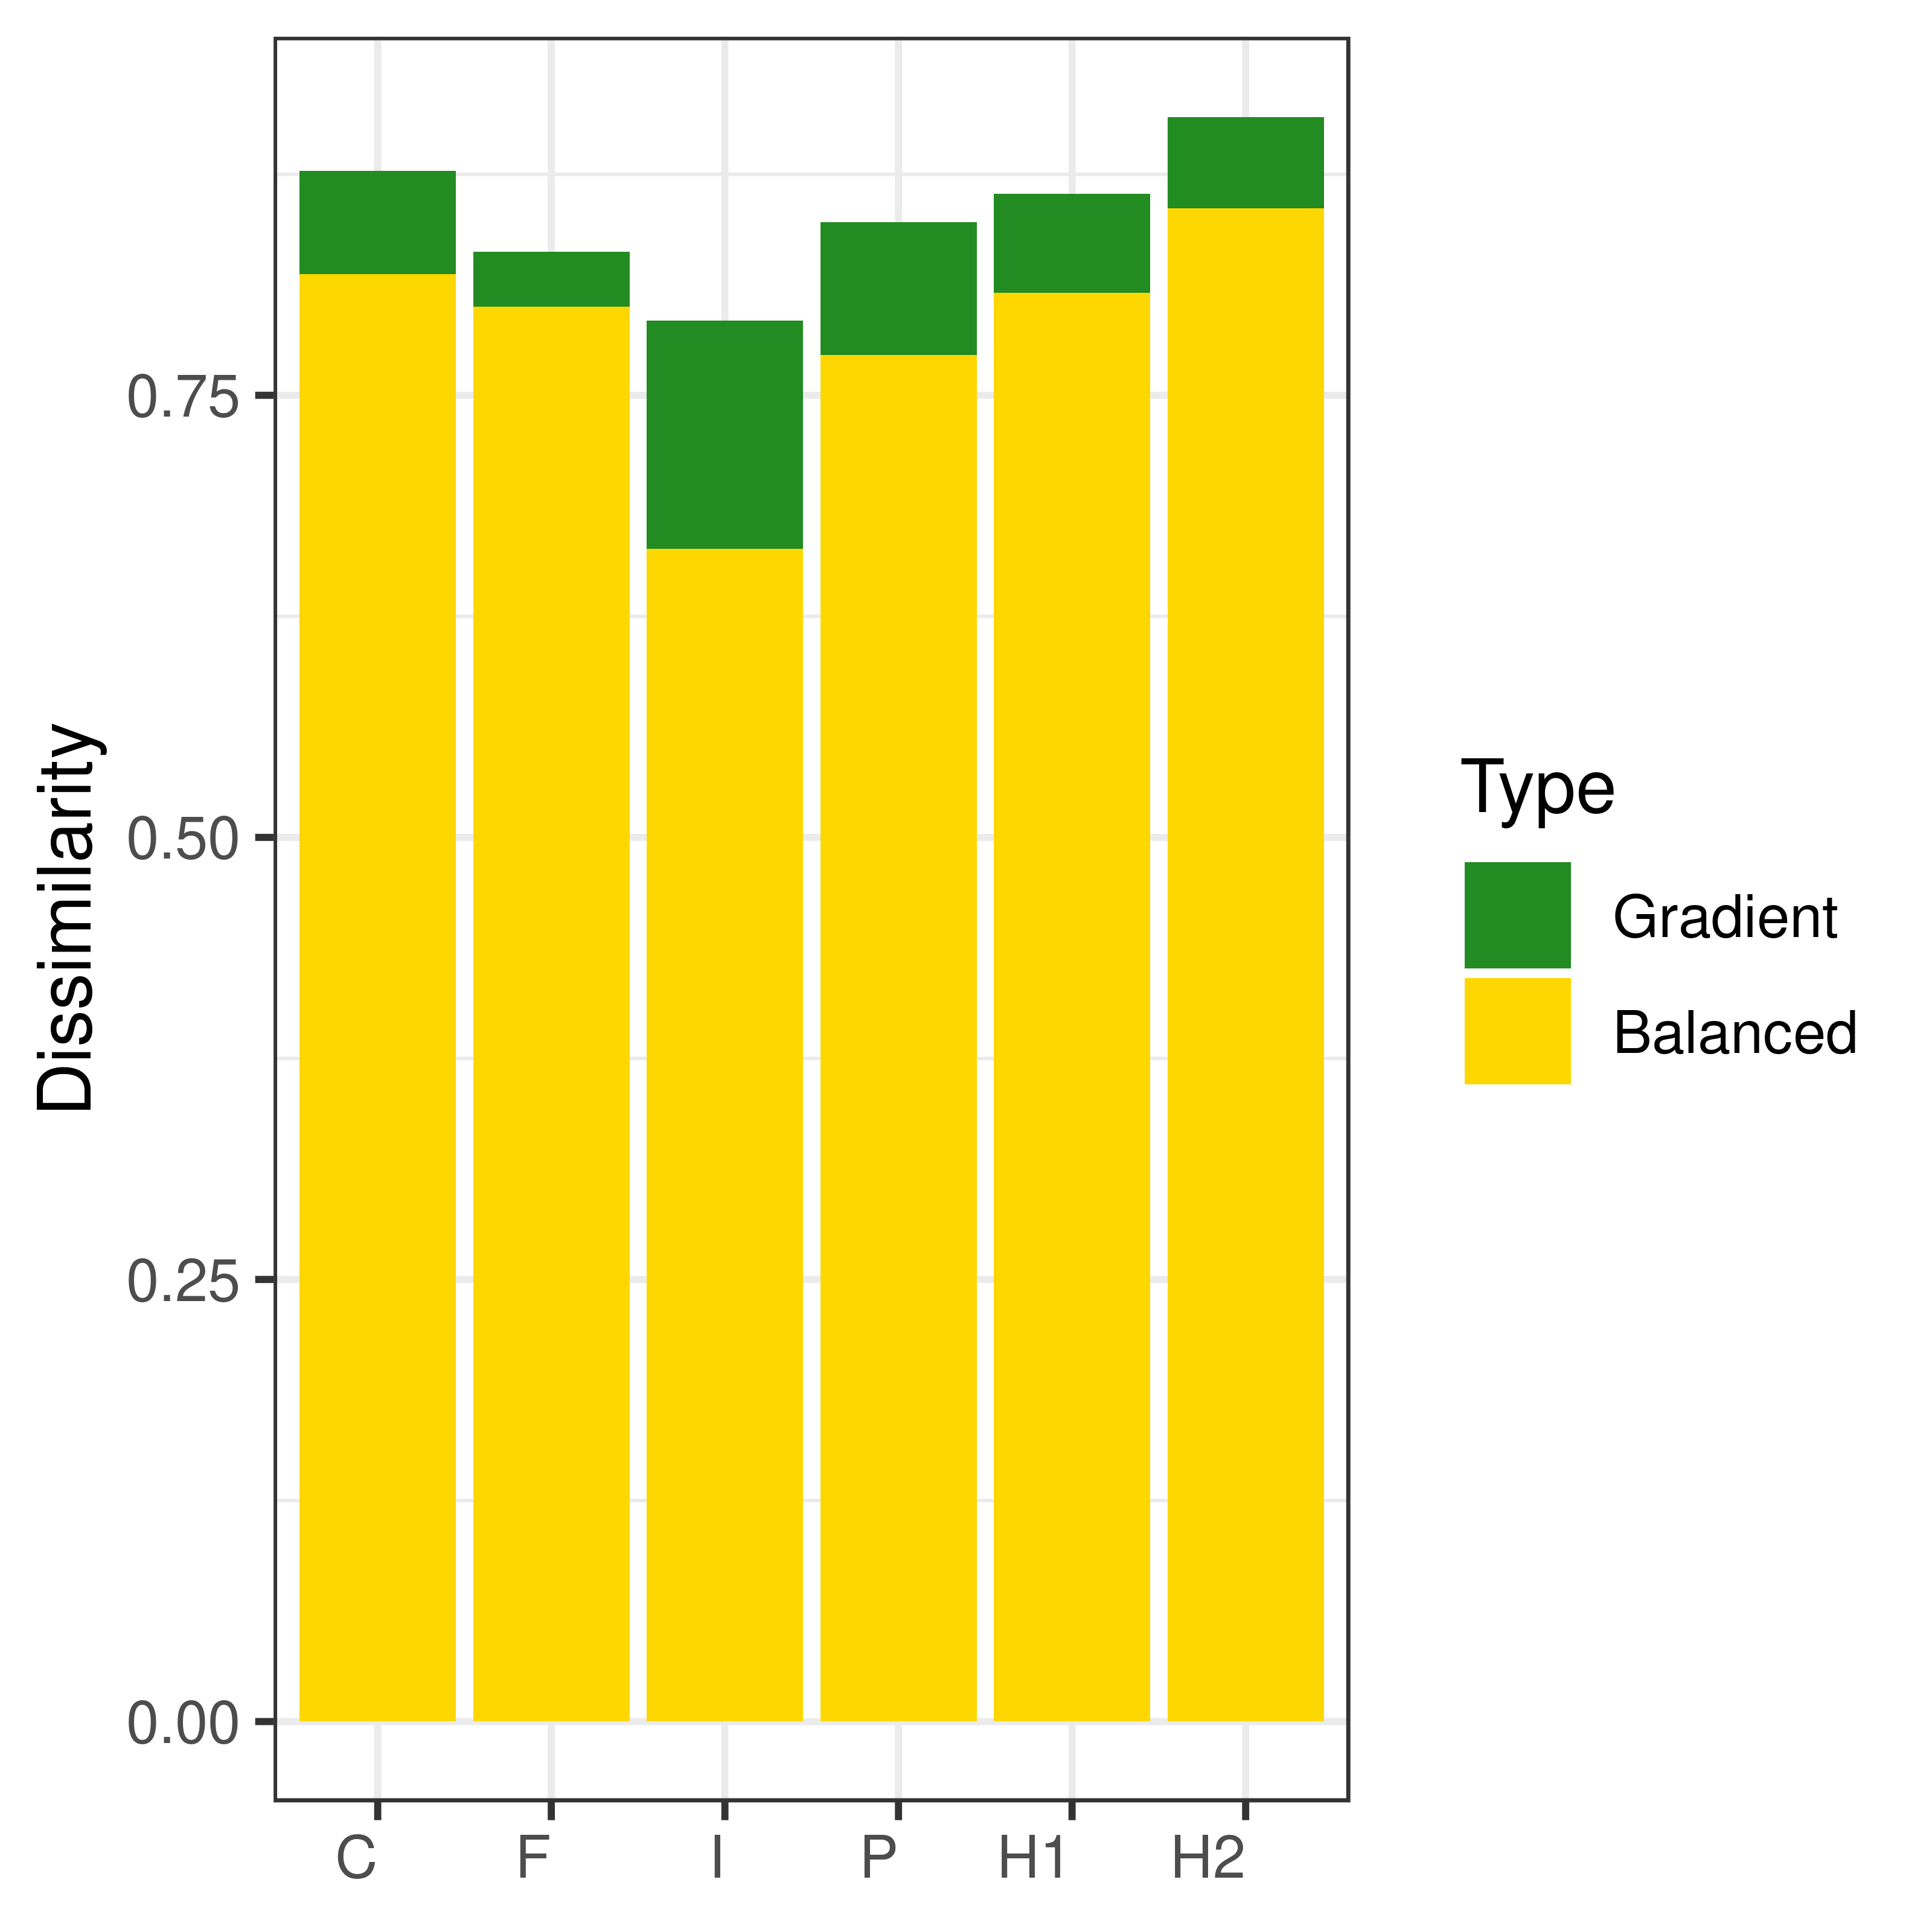Fig S3. Total within-treatment beta-diversity values partitioned into turnover (Balanced) and nestedness (Gradient) variation components. C – control, F – fungicide treatment, H1 – moderate increase in herbivory, H2 – high increase in herbivory, I – insecticide treatment, P – birds, bats and ants exclusion.

## *Analysis of the most prevalent species*

## 

Fig S4. Relative abundance of the most prevalent species across experimental communities in pairwise comparisons between control and other treatments. Maximum likelihood estimates for the mean and 95% CI are plotted over individual data points. Significance of differences were determined using linear model with beta error distribution. Colors represent significance at alpha=0.05 (red) and alpha=0.1 (orange). C – control, F – fungicide treatment, H1 – moderate increase in herbivory, H2 – high increase in herbivory, I – insecticide treatment, P – birds, bats and ants exclusion.

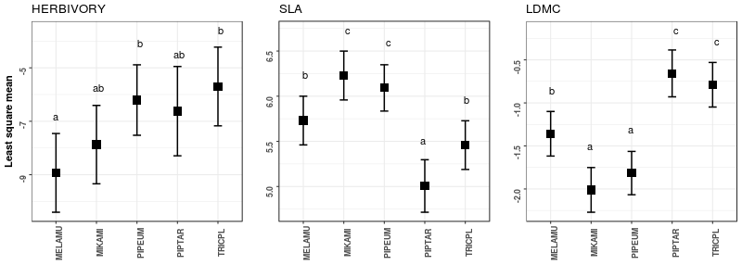Fig. S5. Average trait values in the control plots evaluated for the five most prevalent species. Significance was calculated with ANOVA and Tukey’s post-hoc test.

## References

Baselga, A. (2017). Partitioning abundance-based multiple-site dissimilarity into components: balanced variation in abundance and abundance gradients. *Methods in Ecology and Evolution*, *8*(7), 799–808. doi:10.1111/2041-210X.12693